Name: Richard Raymond J. Canda

C.Y.S.: BSCpE - 3A

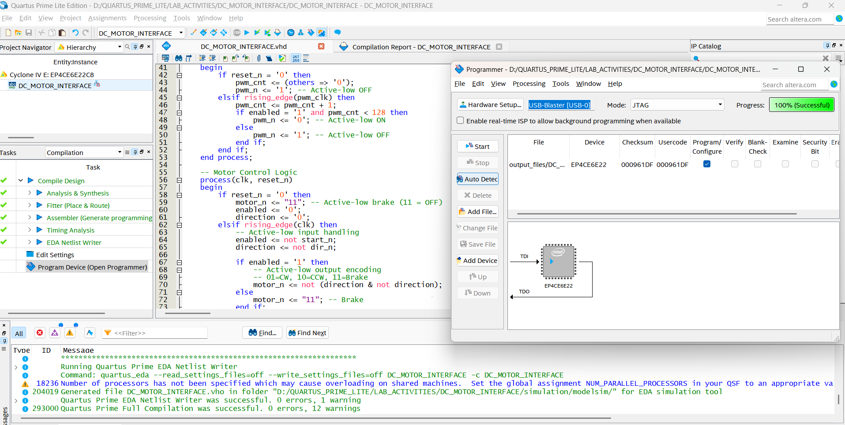

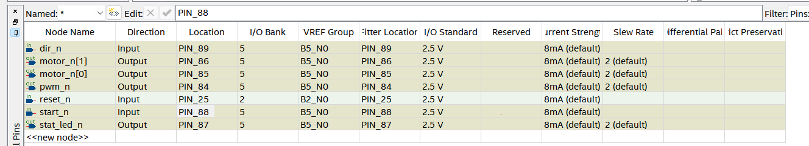

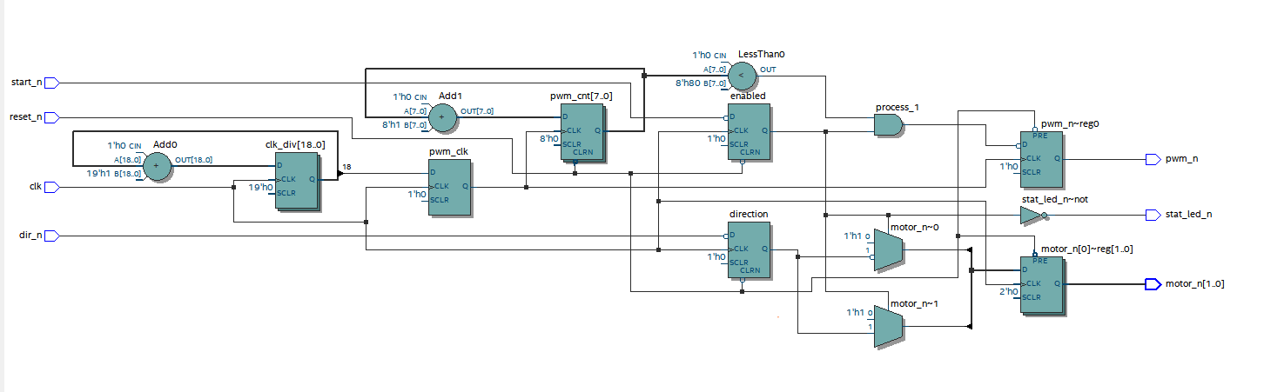

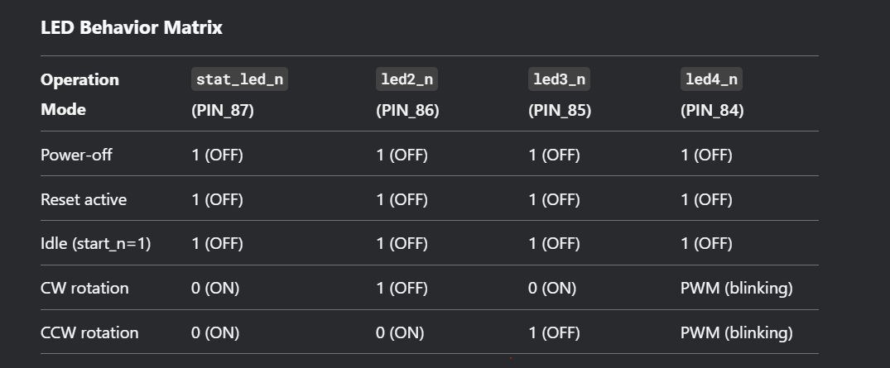

**DC MOTOR INTERFACE**

library IEEE;

use IEEE.STD_LOGIC_1164.ALL;

use IEEE.NUMERIC_STD.ALL;

entity DC_MOTOR_INTERFACE is

Port (

-- Active-low control inputs

clk : in STD_LOGIC; -- PIN_23 (50MHz)

reset_n : in STD_LOGIC; -- PIN_25 (RESET button)

start_n : in STD_LOGIC; -- PIN_88 (KEY1)

dir_n : in STD_LOGIC; -- PIN_89 (KEY2)

-- Active-low outputs

pwm_n : out STD_LOGIC; -- PIN_84 (led4)

motor_n : out STD_LOGIC_VECTOR(1 downto 0); -- PIN_85,86 (led3,led2)

-- Active-low status LED

stat_led_n : out STD_LOGIC -- PIN_87 (led1)

);

end DC_MOTOR_INTERFACE;

architecture Behavioral of DC_MOTOR_INTERFACE is

signal pwm_cnt : unsigned(7 downto 0) := (others => '0');

signal clk_div : unsigned(18 downto 0) := (others => '0');

signal pwm_clk : STD_LOGIC := '0';

signal enabled : STD_LOGIC := '0';

signal direction : STD_LOGIC := '0';

begin

-- Clock divider (50MHz → 95Hz)

process(clk)

begin

if rising_edge(clk) then

clk_div <= clk_div + 1;

pwm_clk <= clk_div(18);

end if;

end process;

-- PWM Generator (active-low output)

process(pwm_clk, reset_n)

begin

if reset_n = '0' then

pwm_cnt <= (others => '0');

pwm_n <= '1'; -- Active-low OFF

elsif rising_edge(pwm_clk) then

pwm_cnt <= pwm_cnt + 1;

if enabled = '1' and pwm_cnt < 128 then

pwm_n <= '0'; -- Active-low ON

else

pwm_n <= '1'; -- Active-low OFF

end if;

end if;

end process;

-- Motor Control Logic

process(clk, reset_n)

begin

if reset_n = '0' then

motor_n <= "11"; -- Active-low brake (11 = OFF)

enabled <= '0';

direction <= '0';

elsif rising_edge(clk) then

-- Active-low input handling

enabled <= not start_n;

direction <= not dir_n;

if enabled = '1' then

-- Active-low output encoding

-- 01=CW, 10=CCW, 11=Brake

motor_n <= not (direction & not direction);

else

motor_n <= "11"; -- Brake

end if;

end if;

end process;

-- Active-low status LED (ON when enabled)

stat_led_n <= not enabled;

end Behavioral;